**Requirement Gathering and Analysis Phase**

**Data Flow Diagram & User Stories**

|  |  |
| --- | --- |
| Date | 06th July , 2024 |
| Team ID | SWTID1720075176 |
| Project Name | Project – Online Complaint Register and Management |
| Maximum Marks |  |

**Data Flow Diagrams:**

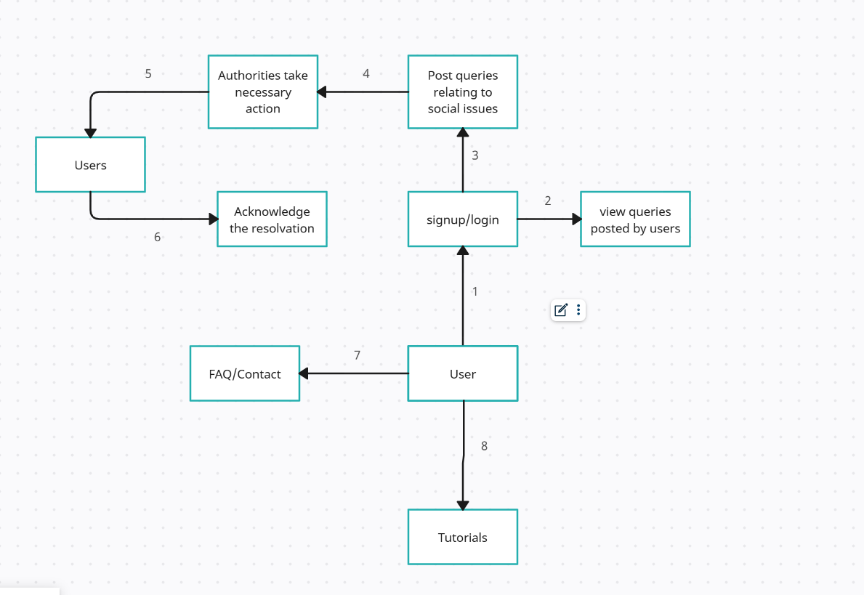

**1.The user signs up and login to the application service.**

**2.The user can view queries posted by other users.**

**3.The user can post his own queries for the authorities to resolve**

**4.The authorities acknowledge the query and take actions to resolve them**

**5.Once resolved the users are notified.**

**6.The user acknowledges back if the issue has been truly resolved**

**7.The user can view the FAQ and can contact authorities using the available contact information**

**8.The user can use the Tutorials offered to efficiently make use of the application.**

**User Stories**

| **User Type** | **Functional Requirement (Epic)** | **User Story Number** | **User Story / Task** | **Acceptance criteria** | **Priority** | **Release** |
| --- | --- | --- | --- | --- | --- | --- |
| Citizen of India | Sign up | USN-1 | As a user, I can sign up for the application by entering my name,email,phone number, ID proof,DOB, password, and confirming my password. | I can access my account / dashboard | High | Sprint-1 |
|  |  | USN-2 | As a user, I will receive confirmation email once I have registered for the application | I can receive confirmation email & click confirm | High | Sprint-1 |
|  | Tutorial | USN-3 | As a user, I can understand how to use the application by watching the tutorial clips and guidance . | I can understand how to use the application | High | Sprint-2 |
|  | FAQ | USN-4 | As a user, I can view frequently asked questions regarding the application for clarification of queries. | I can view frequently asked questions | Low | Sprint-2 |
|  | Contact | USN-5 | As a user, I can use the contact page for contacting the technicians and authorities handling the page for assistance | I can use contacts for assistance | Medium | Sprint-2 |
|  | Login | USN-6 | As a user, I can log into the application by entering email & password | I can log into the application by entering email & password | High | Sprint-1 |
|  | Dashboard | USN-7 | As a user, I can view queries posted by other users regarding the social problems in each constituency. | I can view queries on the dashboard | High | Sprint-1 |
|  |  | USN-8 | I can choose to post problems using the problems tab | I can post new queries | High | Sprint-1 |
|  |  | USN-9 | I can choose the constituency , describe my query, post photos and videos of the problem as proof | I can post my problem with proof and details | High | Sprint-1 |
|  |  | USN-10 | As a user, I can check the progress of the authorities undertaking the redressal | I can check progress of the process | Medium | Sprint-2 |
|  |  | USN-11 | As a user, I can acknowledge that the issue as been resolved by the authorities to complete the redressal | I can confirm that the problem is resolved | High | Sprint-1 |
|  |  | USN-12 | As a user, I can endorse a stated problem by clicking on the endorsement button stating that the problem exists in reality. | I can give approval for existing problems | Medium | Sprint-2 |
|  |  |  |  |  |  |  |
|  |  |  |  |  |  |  |
|  |  |  |  |  |  |  |